BREAKTHROUGH CENTER INTERNATIONAL MINISTRIES

INTERNATIONAL
INTERNATIONAL

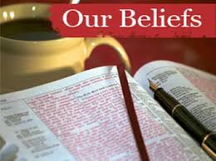
ARTICLES OF FAITH
We believe -The Bible is the Word of God in its entirety, fully inspired and without error in the original manuscripts written under the inspiration of the Holy Spirit and it has a supreme authority in all matters of faith and conduct. II Peter 1:20-21. There is only one true and living God. The Father, son and Holy Spirit are equal in power. Jesus Christ, God’s Son, is 100% man and 100% God. All have sinned and are in need of God’s saving grace. Salvation is not earned, but is a free gift from God. God still manifests his power and presence on earth. In the personal and visible return of Jesus Christ to the earth: These are doctrinal truths or the things that the church believes in according to the Bible. They are teachings of faith about God, Jesus, the Holy Spirit and our salvation and which guide the Church and inspire faith as well as definitions and explanations of various aspects of the Church's practices.
Article 1: the Scriptures We believe that the Bible is the word of God, supernaturally inspired, that it is inerrant in the original manuscripts and preserved by God in its verbal, plenary inspiration, and that it is a divinely authoritative standard for every age and life (II Timothy 3:15-17; I Thessalonians 2:13; II Peter 1:21)
The Holy Scriptures: We believe in the Holy Scriptures, both the Old and New Testaments, are inspired of God and are the revelation of God to humankind, the infallible, authoritative rule of faith and conduct (2 Timothy 3:15-17;
1 Thessalonians 2:13; 2 Peter 1:21).

Article 2: God
We believe that the Godhead exists eternally in three person- Father, Son and the Holy Spirit-and these three are one God (Deuteronomy 6:4; Isaiah 43:10-11; Matthew 28:19; Luke 3:22) IN God as absolute and sole Creator of the universe, and that creation was by the divine providence of God, not through evolutionary process (Genesis 1:1; Nehemiah 9:6, Hebrew 11:3).

The One True God: We believe in the One True and living God, who is everlasting, infinite in power, wisdom and goodness; who is the Creator of all things, visible and invisible, and preserver of all things (Romans 1:20; Colossians 1:16) and who reveals Himself as three Persons of one individual essence, who are co-equal, co-existent and co-eternal; namely, the Father, the Son and the Holy Spirit (Matthew 3:16, 17; Matthew 28:18, 19; 2 Corinthians 13:14; John 1:1, 2, 18; Philippians 2:6; Hebrews 9:14; John 14:26; 15:26; John 10:33).

B. God the Son
We believe that Jesus Christ in the flesh was both God and men, that He was born of a virgin and that he lived a sinless life, in which he taught and did mighty works and wonders and signs exactly as revealed in the gospels, that He was crucified, died as a penalty for our sins and raised from the dead bodily on the third day. Later, He ascended to the Father’s right hand where He is head of the Church and interceding for believers, and from which He is coming again, bodily and visibly to the earth to the earth to receive us into His kingdom
(Matthew 1:23; I Peter 2:22; Acts 2:22’ I Corinthians 15:3; Acts 2:33).
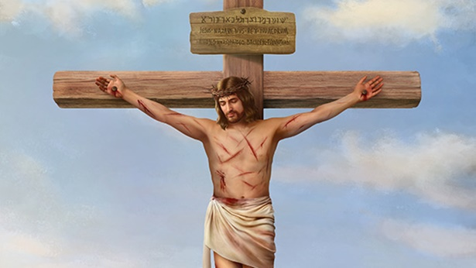

THAT God by His sovereign choice and out of eternal love for mankind, sent His only begotten Son, Jesus Christ, into the world to save sinners
(John 3:16; Romans 5:8).

THAT since in His death, by the blood, the Lord Jesus Christ made a perfect atonement for sin, redeeming us from the curse of the law by becoming a curse for us, we are saved and justified on the simple and single ground of the shed blood (Galatians 3:15; Romans 5:1).
THAT such salvation with its forgiveness of sins, new nature and its hope of eternal life, is entirely apart from works, baptism, church membership – or man’s effort- and is of pure grace (Ephesians 2:8; Titus 3:7).

THAT all who receive Christ become joint-heirs with Christ, and at death, their spirits depart to be with Christ and at the rapture their bodies will be raised to the likeness of the body of his glory and dwell forever in his divine presence (Romans 8:17; I Thessalonians 4:16-17)

C. The Holy Spirit
We believe that the Holy Spirit is a person in God and possesses all the divine attributes. He indwells all believers, baptizes and seals them, and fills them in response to confession of sin and yielding (I Corinthians 1:22; 3:16).

THAT it is the goal of every Christian to grow in spiritual maturity through obedience to the word of God and the indwelling Spirit (II Peter 2:18; 1:5-6)

Article 3: Man
Man is the special creation of God, made in His own image. He created them male and female as the crowning work of His creation. The gift of gender is thus part of the goodness of God's creation. In the beginning man was innocent of sin and was endowed by his Creator with freedom of choice. By his free choice man sinned against God and brought sin into the human race. Through the temptation of Satan man transgressed the command of God, and fell from his original innocence whereby his posterity inherits a nature and an environment inclined toward sin. Therefore, as soon as they are capable of moral action, they become transgressors and are under condemnation.

Only the grace of God can bring man into His holy fellowship and enable man to fulfill the creative purpose of God. The sacredness of human personality is evident in that God created man in His own image, and in that Christ died for man; therefore, every person of every race possesses full dignity and is worthy of respect and Christian love. Genesis 1:26-30; 2:5,7,18-22; 3; 9:6; Psalms 1; 8:3-6; 32:1-5; 51:5; Isaiah 6:5; Jeremiah 17:5; Matthew 16:26;

The Fall of Humankind: We believe that humankind was created good and upright; for God said, “Let us make man in our image, after our likeness.” However, man by voluntary transgression fell and thereby incurred not only physical death but also spiritual death, which is separation from God and need repentance and regeneration (Genesis 1:26,27; 2:17; 3:6; Romans 5:12–19; Isaiah 53:6).
SALVATION
Article 4: Salvation
Salvation involves the redemption of the whole man, and is offered freely to all who accept Jesus Christ as Lord and Savior, who by His own blood obtained eternal redemption for the believer. In its broadest sense salvation includes regeneration, justification, sanctification, and glorification. There is no salvation apart from personal faith in Jesus Christ as Lord.

The Salvation of Humankind: We believe humankind’s only hope of redemption has been made possible through the meritorious work of Jesus Christ on the cross and through the Holy Spirit conviction. Godly sorrow works repentance and makes possible the experience of the new birth, and Christ formed within us is the gift of eternal life (Titus 2:11; Rom. 10:13-15; Luke 24:47;Titus 3:5-7).

A. Regeneration, or the new birth, is a work of God's grace whereby believers become new creatures in Christ Jesus. It is a change of heart wrought by the Holy Spirit through conviction of sin, to which the sinner responds in repentance toward God and faith in the Lord Jesus Christ. Repentance and faith are inseparable experiences of grace. Repentance is a genuine turning from sin toward God. Faith is the acceptance of Jesus Christ and commitment of the entire personality to Him as Lord and Savior.

B. Justification is God's gracious and full acquittal upon principles of His righteousness of all sinners who repent and believe in Christ. Justification brings the believer unto a relationship of peace and favor with God.

C. Sanctification is the experience, beginning in regeneration, by which the believer is set apart to God's purposes, and is enabled to progress toward moral and spiritual maturity through the presence and power of the Holy Spirit dwelling in him. Growth in grace should continue throughout the regenerate person's life.

We believe that sanctification is an act of separation from that which is evil, and of dedication unto God (Romans 12:1,2; 1 Thessalonians 5:23; Heb. 13:12). Scriptures teach a life of “holiness without which no man shall see. the Lord” (Hebrews 12:14). We believe in the doctrine of sanctification as a definite, yet progressive, work of grace, commencing at the time of regeneration and continuing until the consummation of salvation (Hebrews 13:12;
2 Thessalonians 2:13; 1 Peter 1:2; Ephesians 5:26; 1 Corinthians 6:11;
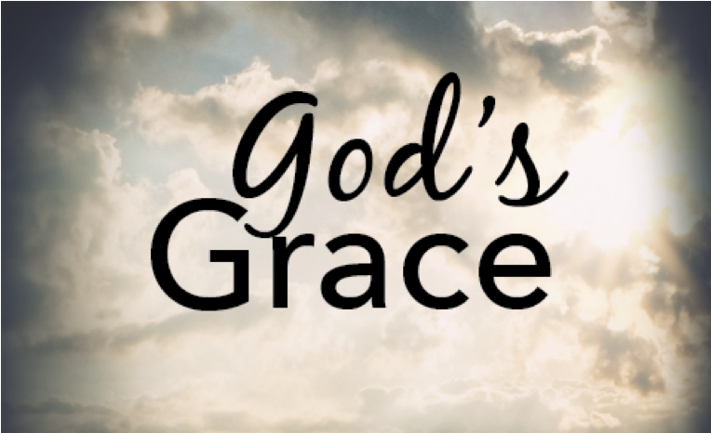

Article 5: God's Purpose of Grace
Election is the gracious purpose of God, according to which He regenerates, justifies, sanctifies, and glorifies sinners. It is consistent with the free agency of man, and comprehends all the means in connection with the end. It is the glorious display of God's sovereign goodness, and is infinitely wise, holy, and unchangeable. It excludes boasting and promotes humility. All true believers endure to the end.

Those whom God has accepted in Christ, and sanctified by His Spirit, will never fall away from the state of grace, but shall persevere to the end. Believers may fall into sin through neglect and temptation, whereby they grieve the Spirit, impair their graces and comforts, and bring reproach on the cause of Christ and temporal judgments on themselves; yet they shall be kept by the power of God through faith unto salvation. Genesis 12:1-3; Exodus 19:5-8; 1 Samuel 8:4-7,19-22; Isaiah 5:1-7; Jeremiah 31:31; Matthew 16:18-19; Luke 1:68-79; John 1:12-14; Acts 20:32; Romans 5:9-10; 8:28-39 1 Corinthians 1:1-2; 15:24-28; Ephesians 1:4-23; 2:1-10; 3:1-11; Colossians 1:12-14; 2 Thessalonians 2:13-14;

D. Glorification is the culmination of salvation and is the final blessed and abiding state of the redeemed. Genesis 3:15; Exodus 3:14-17; 6:2-8; Matthew 1:21. Luke 1:68-69; 2:28-32; John 1:11-14, Acts 2:21; Romans 1:16-18:1 Corinthians 1:18,30; 6:19-20; 15:10; 2 Corinthians 5:17-20; Galatians 2:20; 3:13; 5:22-25; 6:15; Ephesians 1:7; 2:8-22; 4:11-16;
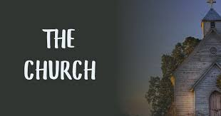

Article 6: The Church
We believe - A New Testament church of the Lord Jesus Christ is an autonomous local congregation of baptized believers, associated by covenant in the faith and fellowship of the gospel; observing the two ordinances of Christ, governed by His laws, exercising the gifts, rights, and privileges invested in them by His Word, and seeking to extend the gospel to the ends of the earth. Each congregation operates under the Lordship of Christ through democratic processes. In such a congregation each member is responsible and accountable to Christ as Lord.

Its scriptural officers are pastors and leaders. While both men and women are gifted for service in the church, the office of pastor is limited to men as qualified by Scripture. The New Testament speaks also of the church as the Body of Christ which includes all of the redeemed of all the ages, believers from every tribe, and tongue, and people, and nation. Matthew 16:15-19; Acts 2:41-42,47; Romans 1:7; 1 Corinthians 1:2; 3:16; Ephesians 1:22-23; 2:19-22; 3:8-11,21; 5:22-32; Philippians 1:1; Colossians 1:18;

The Ordinances (Sacraments) of the Church:
We believe in the two ordinances of the church, baptism of water by immersion for all those who repent and believe on Christ as Savior and Lord, and the Holy Communion or Lord’s Supper expressing our sharing the divine nature of our Lord Jesus Christ and a memorial of His suffering and death (Matthew 28:19; Mark 16:16; Romans 6:4; 1 Cor. 11:26; 2 Peter
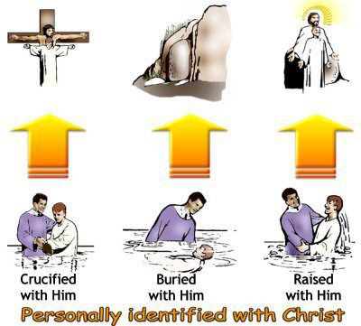

Article 7: A. Baptism
Christian baptism is the immersion of a believer in water in the name of the Father, the Son, and the Holy Spirit. It is an act of obedience symbolizing the believer's faith in a crucified, buried, and risen Savoir, the believer's death to sin, the burial of the old life, and the resurrection to walk in newness of life in Christ Jesus. It is a testimony to his faith in the final resurrection of the dead being a church ordinance; it is prerequisite to the privileges of church membership and to the Lord's Supper.

The Baptism, Gifts and Fruit of the Holy Spirit: We believe the baptism in the Holy Spirit with speaking in other tongues as the Holy Spirit Himself gives utterance as the initial physical sign and evidence for all believers - this experience is distinct from and subsequent to the experience of the new birth. Also, we believe in the operation of the gifts of the Holy Spirit and bearing of fruits in the lives of believers (Mark 16:17; Acts 2:4; 8:12-17; 1 Corinthians 12:8-11; Galatians 5:22-23).

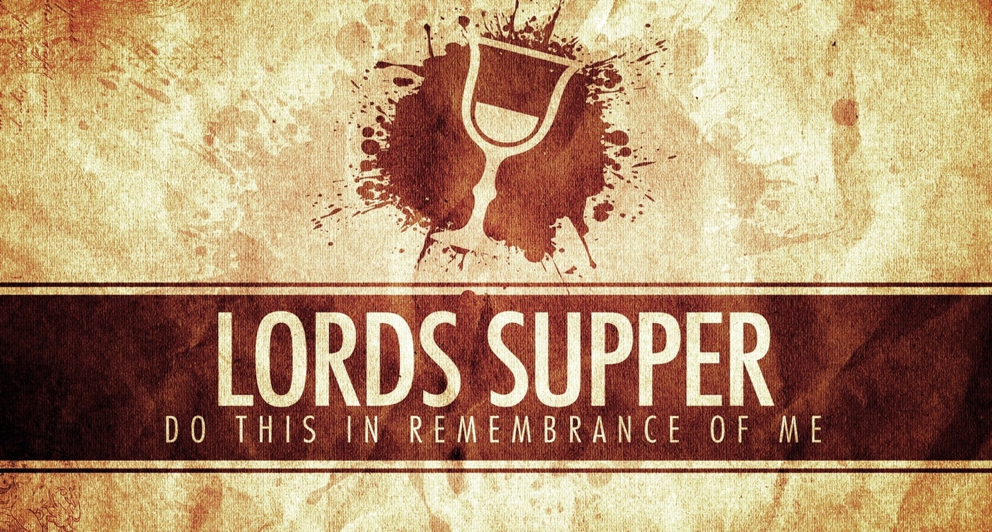

B. the Lord's Supper:
The Lord's Supper is a symbolic act of obedience whereby members of the church, through partaking of the bread and the fruit of the vine, memorialize the death of the Redeemer and anticipate His second coming. Matthew 3:13-17; 26:26-30; Luke 3:21-22; 22:19-20; John 3:23; Acts 2:41-42; 8:35-39; 16:30-33; 20:7; Romans 6:3-5; 1 Corinthians 10:16,21; 11:23-29;
Divine Healing: We believe that divine healing is a vital part of the gospel. Deliverance from sickness is provided for in the Atonement, and is the privilege of all believers, however we do not oppose the use of medical technology for healing purposes (Isaiah 53:4,5; Matthew 8:16,17; James 5:14–16; 2 Kings 20:7).

Article 8: The Lord's Day
The first day of the week is the Lord's Day. It is a Christian institution for regular observance. It commemorates the resurrection of Christ from the dead and should include exercises of worship and spiritual devotion, both public and private. Activities on the Lord's Day should be commensurate with the Christian's conscience under the Lordship of Jesus Christ. (Exodus 20:8-11; Matt. 12:1-12; 28:1ff.; Mk 2:27-28; 16:1-7; Luke 24:1-3,33-36; John 4:21- 24; 20:1,19-28; Acts 20:7; Rom. 14:5-10; I Corinthians. 16:1-2; Col. 2:16; 3:16;

- It's about Jesus. As Christians, we are recipients of God's grace. Grace is when God gives us that which we do not deserve. His grace provides forgiveness, transforms us, sustains us, and enables our service. We are so dependent upon God's grace that we have no room to look down on others. Rather, we are to minister grace to others. We want our church to be a haven of grace.

- Jesus Christ is the Head of the church and its only owner. Let no member think that long service or large gifts impart tenure in an office or control over any part of the ministry.

- While cultures and traditions may change, God's Word is eternal and absolutely reliable in all that it affirms. Therefore, the Bible shall have the final say in all that the church believes, teaches, and does. God's Word is God's tool in maturing disciples.

- We purpose to teach believers from the Bible in practical terms how to live the Christian life. We will train them in Biblical doctrine and for Christian service.

- Christianity is a relationship with Jesus Christ. Thus, we want to be close to Him. We will nurture this relationship each day by spending time with God in prayer and in His Word. No church rises above its prayer life; we will emphasize the practice of prayer

- In the planning process, our priority shall be to pray and make decisions at the leading of the Holy Spirit, instead of making our plans and then asking God to bless them.

- The Christian life is a quest for holiness. We desire to align our actions, words, attitudes, and affections with the nature of God. We will “feed” our inner life to be made strong in the Lord, refraining from anything that weakens our resolve for righteousness, such as pornography or abuse of drugs or alcohol.

- Evangelism is the main work of the whole church until Christ returns. We commit ourselves to intentionally and engagingly sharing the gospel. We emphasize evangelizing those outside the church as well as our own to reach the Charlotte areas and it environs for Jesus Christ.

- Because people are most effectively reached for Christ together with others of like interests, we shall identify and concentrate on reaching out to "people groups" within our community.

- Mission is evangelism which crosses geographical and/or cultural boundaries. Our commitment to world evangelization includes participating in missions and supporting those who give their lives to this work.

- We see ourselves, in part, as a support group for recovering sinners. We purpose to nurture each others' spiritual growth by encouraging one another and holding each other accountable in his walk with Christ.

- In its normal state, the church exists in a unity produced by the Holy Spirit. Disunity results from our own selfish motives and actions. We purpose to preserve this unity by refraining from gossip, a critical spirit, and dis-unifying behavior.

- Change and flexibility being essential to church growth, we will regularly evaluate church ministries and programs. We commit ourselves to excellence in the Lord's work. It is better to do a few things well than many things poorly. Excellence is worth the price of time, money, and energy.

- The church is the body of Christ. The whole church is the body, not just the pastor and staff. Thus, we commit ourselves to helping members discover their spiritual gifts and mobilizing every member in service to Jesus Christ. We view the pastor and staff as shepherds and disciples who equip the church for the work of ministry (Ephesian 4:1-12).

- It is every member’s responsibility to promote the mission, protect the reputation, and ensure the success of the church. Worship involves both joyful celebration and reverent contemplation. We will do both with the focus on Jesus Christ. We purpose to support and uphold the ideal of the Christian home. A Christian marriage involves a man and woman, both believers, living according to Biblical principles, committed to each other exclusively for life, and seeking to rear godly children.

Article 9: The Kingdom
The Kingdom of God includes both His general sovereignty over the universe and His particular kingship over men who willfully acknowledge Him as King. Particularly the Kingdom is the realm of salvation into which men enter by trustful, childlike commitment to Jesus Christ. Christians ought to pray and to labor that the Kingdom may come and God's will be done on earth. The full consummation of the Kingdom awaits the return of Jesus Christ and the end of this age. Gen. 1:1; Isa. 9:6-7; Jer. 23:5-6; Matt. 3:2; 4:8-10,23; Mark 1:14-15; 9:1;

Article 10: Last Things
God, in His own time and in His own way, will bring the world to its appropriate end. According to His promise, Jesus Christ will return personally and visibly in glory to the earth; the dead will be raised; and Christ will judge all men in righteousness. The unrighteous will be consigned to Hell, the place of everlasting punishment. The righteous in their resurrected and glorified bodies will receive their reward and will dwell forever in Heaven with the Lord. Isaiah 2:4; 11:9; Matthew 16:27; 18:8-9; Mark 8:38; 9:43-48; Luke 12:40, 48; 16:19-26; 17:22-37; 21:27-28;

The Second Coming of Christ and the Next Life: We believe in the Second Coming of Christ and the Resurrection of the dead, both saved and unsaved; they that are saved, to the resurrection of life, and they that are unsaved, to the resurrection of condemnation. (Mark 13:26; Daniel 12:2; John 5:28-29; Romans 2:7-11; 6:23).
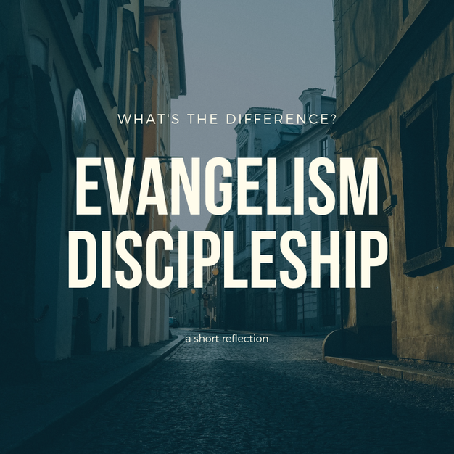

Article 11: Evangelism and Missions
It is the duty and privilege of every follower of Christ and of every church of the Lord Jesus Christ to endeavor to make disciples of all nations. The new birth of man's spirit by God's Holy Spirit means the birth of love for others. Missionary effort on the part of all rests thus upon a spiritual necessity of the regenerate life, and is expressly and repeatedly commanded in the teachings of Christ. The Lord Jesus Christ has commanded the preaching of the gospel to all nations. It is the duty of every child of God to seek constantly to win the lost to Christ by verbal witness undergirded by a Christian lifestyle, and by other methods in harmony with the gospel of Christ. Genesis 12:1-3; Exodus 19:5-6; Isaiah 6:1-8; Matthew 9:37-38; 10:5-15; 13:18-30, 37-43;

Article 12: Education
Christianity is the faith of enlightenment and intelligence. In Jesus Christ abide all the treasures of wisdom and knowledge. All sound learning is, therefore, a part of our Christian heritage. The new birth opens all human faculties and creates a thirst for knowledge. Moreover, the cause of education in the Kingdom of Christ is co-ordinate with the causes of missions and general benevolence, and should receive along with these the liberal support of the churches.

An adequate system of Christian education is necessary to a complete spiritual program for Christ's people. In Christian education there should be a proper balance between academic freedom and academic responsibility. Freedom in any orderly relationship of human life is always limited and never absolute. The freedom of a teacher in a Christian school, college, or seminary is limited by the preeminence of Jesus Christ, by the authoritative nature of the Scriptures, and by the distinct purpose for which the school exists. Deut. 4:1,5,9,14; 6:1-10; 31:12-13; Neh. 8:1-8; Job 28:28; Psalms 19:7ff.; 119:11; Proverbs 3:13: 4:1-10.
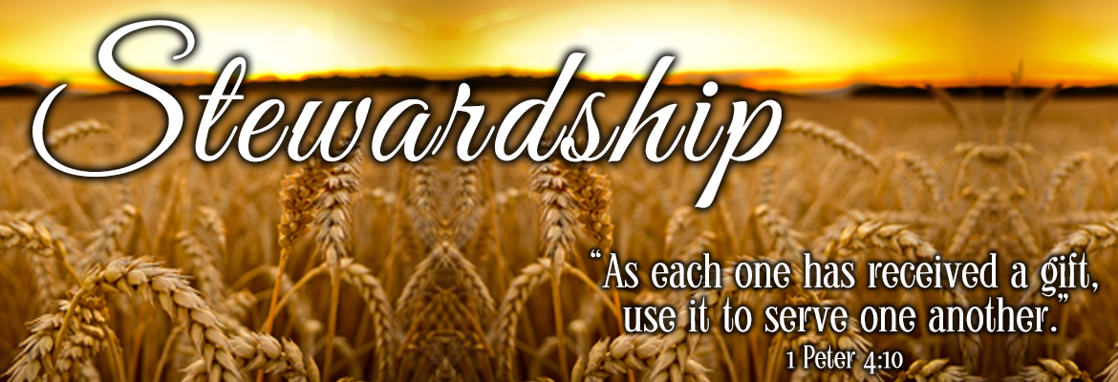

Article 13: Stewardship
God is the source of all blessings, temporal and spiritual; all that we have and are we owe to Him. Christians have a spiritual debtor ship to the whole world, a holy trusteeship in the gospel, and a binding stewardship in their possessions. They are therefore under obligation to serve Him with their time, talents, and material possessions; and should recognize all these as entrusted to them to use for the glory of God and for helping others. According to the Scriptures, Christians should contribute of their means cheerfully, regularly, systematically, proportionately, and liberally for the advancement of the Redeemer's cause on earth. Genesis 14:20; Leviticus 27:30-32; Deuteronomy 8:18; Malachi 3:8-12; Matthew 6:1-4,19-21; 19:21; 23:23; 25:14-29;

Tithing and Offering: We believe and recognize the Scriptural duty of all our people, as well as ministers and officers, to pay tithes as unto the Lord (Hebrews 7:8) and in giving of freewill offerings. Tithes should be used for the support of the ministry and for the propagation of the gospel and work of the Lord in general. For God blesses a cheerful giver (Malachi 3:6-11; Hebrews 7:2; 1 Corinthians 9:7-11; 16:2; Acts 10:35; Matthew 23:23).

The Bible teaches that everything in our lives – time, abilities, and finances – belongs to the Lord and that we are to manage His resources in His way. As God has entrusted His message to us, believers are stewards of the gospel. In regard to financial giving, the tithe is the starting place. We owe God a tithe; offerings are expressions of worship above the tithe. We believe in “storehouse tithing,” giving the first ten percent through the general church budget. Malachi 3:8; Malachi 3:10; Matthew 6:19-20

Article 14: Cooperation
We believe Christ's people should, as occasion requires, organize such associations and conventions as may best secure cooperation for the great objects of the Kingdom of God. Such organizations have no authority over one another or over the churches. They are voluntary and advisory bodies designed to elicit, combine, and direct the energies of our people in the most effective manner. Members of New Testament churches should cooperate with one another in carrying forward the missionary, educational, and benevolent ministries for the extension of Christ's Kingdom.

Christian unity in the New Testament sense is spiritual harmony and voluntary cooperation for common ends by various groups of Christ's people. Cooperation is desirable between the various Christian denominations, when the end to be attained is itself justified, and when such cooperation involves no violation of conscience or compromise of loyalty to Christ and His Word as revealed in the New Testament. Exodus 17:12; 18:17; Judges 7:21; Ezra 1:3-4; 2:68-69;

Article 15: The Christian and the Social Order
We believe - All Christians are under obligation to seek to make the will of Christ supreme in our own lives and in human society. Means and methods used for the improvement of society and the establishment of righteousness among men can be truly and permanently helpful only when they are rooted in the regeneration of the individual by the saving grace of God in Jesus Christ.

We believe in the spirit of Christ, Christians should oppose racism, every form of greed, selfishness, and vice, and all forms of sexual immorality, including adultery, homosexuality, and pornography. We should work to provide for the orphaned, the needy, the abused, the aged, the helpless, and the sick. We should speak on behalf of the unborn and contend for the sanctity of all human life from conception to natural death.

Every Christian should seek to bring industry, government, and society as a whole under the sway of the principles of righteousness, truth, and brotherly love. In order to promote these ends Christians should be ready to work with all men of good will in any good cause, always being careful to act in the spirit of love without compromising their loyalty to Christ and His truth.
Exodus 20:3-17; Leviticus 6:2-5; Deuteronomy 10:12; 27:17; Psalm 101:5; Micah 6:8; Zechariah 8:16; Matthew 5:13-16, Romans 12–14; 1Corinthians 5:9-10; 6:1-7; 7:20-24; 10:23-11:1; Galatians 3:26-28; Ephesians 6:5-9; Colossians

Article 16: Peace and War
We believe It is the duty of Christians to seek peace with all men on principles of righteousness. In accordance with the spirit and teachings of Christ they should do all in their power to put an end to war. The true remedy for the war spirit is the gospel of our Lord. The supreme need of the world is the acceptance of His teachings in all the affairs of men and nations, and the practical application of His law of love. Christian people throughout the world should pray for the reign of the Prince of Peace. Isaiah 2:4; Matthew 5:9, 38-48; 6:33; 26:52; Luke 22:36, 38; Rom. 12:18-19; 13:1-14:19; Heb. 12:14; James 4:1-2.

Article 17: The Family
We believe - God has ordained the family as the foundational institution of the human society. It is composed of persons related to one another by marriage, blood, or adoption. Marriage is the uniting of one man and one woman in covenant commitment for a lifetime. It is God's unique gift to reveal the union between Christ and His church and to provide for the man and the woman in marriage the framework for intimate companionship, the channel of sexual expression according to biblical standards, and the means for procreation of the human race. The husband (Man) and wife (woman) are of equal worth before God, since both are created in God's image.

The marriage relationship models the way God relates to His People A husband is to love his wife as Christ loved the church. He has the God-given responsibility to provide for, to protect, and to lead his family. A wife is to submit herself graciously to the servant leadership of her husband even as the church willingly submits to the headship of Christ. She, being in the image of God as is her husband and thus equal to him, has the God-given responsibility to respect her husband and to serve as his helper in managing the household and nurturing the next generation. Children, from the moment of conception, are a blessing and heritage from the Lord.

Parents are to demonstrate to their children God's pattern for marriage. Parents are to teach their children spiritual and moral values and to lead them, through consistent lifestyle example and loving discipline, to make choices based on biblical truth. Children are to honor and obey their parents.
Genesis 1:26-28; 2:15-25; 3:1-20; Exodus 20:12; Deuteronomy 6:4-9;
Joshua 24:15; 1 Samuel 1:26-28; Psalms 51:5; 78:1-8; 127; 128; 139:13-16
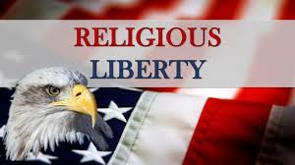
Article 18: Religious Liberty
We believe - God alone is Lord of the conscience, and He has left it free from the doctrines and commandments of men which are contrary to His Word or not contained in it. Church and state should be separate. The state owes to every church protection and full freedom in the pursuit of its spiritual ends. In providing for such freedom no ecclesiastical group or denomination should be favored by the state more than others. Civil government being ordained of God; it is the duty of Christians to render loyal obedience thereto in all things not contrary to the revealed will of God. The church should not resort to the civil power to carry on its work.

The gospel of Christ contemplates spiritual means alone for the pursuit of its ends. The state has no right to impose penalties for religious opinions of any kind. The state has no right to impose taxes for the support of any form of religion. A free church in a free state is the Christian ideal, and this implies the right of free and unhindered access to God on the part of all men, and the right to form and propagate opinions in the sphere of religion without interference by the civil power. Genesis 1:27; 2:7; Matthew 6:6-7,24; 16:26; 22:21; John 8:36; Acts 4:19-20; Romans 6:1-2; 13:1- 7; Galatians 5:1,13; Philippians 3:20;
1 Timothy 2:1-2; James 4:12; 1 Peter 2:12-17;

